To register on an award, follow the steps below:
To access any GAA course you need to have registered on the learning.gaa.ie portal.

If you need to REGISTER a profile on the learning portal:
Using your phone camera: SCAN the 1st QR code, at STEP 1.

(Registering a profile is required to give GDPR consent for us to hold data and takes about 3 mins. The rest is a click tab process so it's very easy).

If you already have registered a profile – Log in to the portal and proceed to STEP 2.

STEP 1 | STEP 2
Registration | Enrolling on course
Use your mobile phone to SCAN this QR code so you can register on the learning portal: | Log on to the portal using your email and password.  SCAN the QR code below and enter the Enrolment Key (CASE SENSITIVE) and that is you registered on the course:
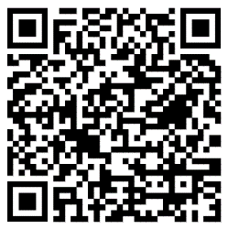 | 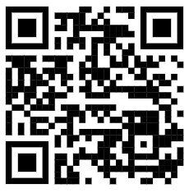
or access the Learning portal using this URL:  https://learning.gaa.ie/user/register | Britain ICGG Dual St Helen’s, Barry, 2nd November 2025  Enrolment Key: JoesD25  or access the course using this URL:  https://learning.gaa.ie/lms/course/view.php?id=23470

